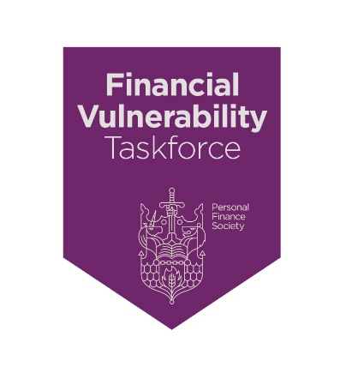
Charter Commitment 7: “We seek to recognise clients in vulnerable circumstances and encourage all to self-declare if appropriate, safe in the knowledge that we will:

        - adapt our business processes and professional services, so our clients do not suffer detriment at any point as we seek to deliver outcomes at least as good as for those who are not in vulnerable circumstances

        - maintain confidentiality and ensure our behaviours are fully compliant with all relevant legislation including The Equality Act (2010), Consumer Protection regulations, The Mental Capacity Act 2005 and data protection including GDPR.

We see application of the above as ‘business as usual’, part of our raison d’etre and not part of a separate compliance or ‘stand-alone’ exercise.”

Why should your approach to vulnerability be such that it is simply part of your normal processes; and how might you achieve that?

You will have read under Point 6 of the Charter why it is so important to refer to ‘clients in vulnerable circumstances’ rather than ‘vulnerable clients.’

This focusses attention on the circumstances that may be creating vulnerability for your client instead of attempting to compile a list of groups of people that might be labelled as ‘vulnerable.’ This does, however, carry a caveat, which is that there are certain characteristics that will mean that some people will always be vulnerable and will require a very specialised approach – this would include someone who has suffered a catastrophic brain injury that has caused a permanent loss of mental capacity, or someone with a mental illness, living in extreme poverty with very little prospect of their circumstances changing.

These few words below are meant to help you to firstly recognise that, like poor health, vulnerability comes in many guises and can occur at any moment, with any person, and may be temporary or permanent. Secondly, is to help you evolve your processes and the way in which you deliver advice and ongoing service to your clients in such a way that you represent a ‘safe pair of hands’ for them so that they achieve the same outcomes they would have achieved had they not been in vulnerable circumstances.

Whilst it is not an exhaustive list, you may wish to consider the tips and guidance set out under Point 6 of this Charter when reviewing your policy, processes, training, and communications

One method might be for you to review your overall approach to clients, but this time through the lens of a person in vulnerable circumstances.

We have all had experience in our lifetimes of friends, family members or work colleagues that have been in vulnerable circumstances; you yourself may have suffered because of a vulnerability at some point in your life. So, taking this very personal approach may be the most effective way of your developing your own approach to the issue of vulnerability.

Think of the four drivers (health, life events, resilience, and capability) including abuse and mental capacity issues that were discussed under Point 6; and start to think of people you know of who may have suffered detriment because of a vulnerability created under these headings.

For example, who do you know that was in poor health and how that impacted upon their lives? Ask yourself, how you as a professional adviser could have provided support, guidance or advice that would have helped them avoid detriment.

The same applies to the other areas of life events, lack of financial or emotional resilience, poor capability, victims of abuse or declining mental capacity. Think of people you know and, if you have the opportunity, talk to them about their experiences and the difficulties they encountered; and what type of professional input would have helped them navigate through their vulnerabilities.

This will naturally lead you to then consider what improvements can you make to the policy you are working under, any additional technical knowledge you need, how you and your team communicate with clients, how you record vulnerabilities and the processes and procedures you adopt within the business that you operate.

There are also several statutory requirements to consider, which include The Equality Act 2010, The Mental Capacity Act 2005, The Trustee Acts 1925 and 2000 and, of course, GDPR.

Please refer to the FCA’s guidance that flowed from GC20/3 – this is a vitally important document for your business and in your professional work with clients. If you are regulated by the FCA, all that you do in helping to support and advise your clients who find themselves in vulnerable circumstances falls under the auspices of the FCAs Treating Customers Fairly regime; and is very much about helping people avoid detriment, because of their circumstances of vulnerability, and achieve the same outcomes they would have achieved had they not been in vulnerable circumstances.

Lastly, there is a very important broader point to make.

We are all part of a profession and we all want to evolve our profession to one that is naturally perceived by the public at large as a ‘safe pair of hands’ even in the face of a crisis, which sometimes happens where a very small minority of our peers choose not to act in their client’s best interests. By you adopting this Charter and implementing improvements to professionally safeguard, support and advise clients in vulnerable circumstances, you in turn play a crucial role in ensuring the profession is widely perceived as the ‘safe pair of hands’ that it is in Society.

When that objective has been achieved, everyone wins!

