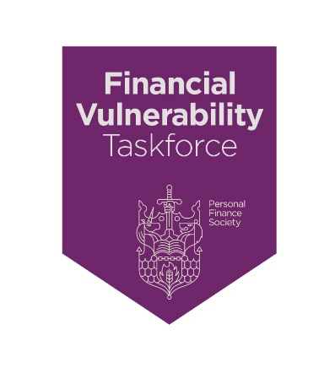
Charter Commitment 6 - “We recognise that people in vulnerable circumstances are often unaware of their vulnerability and, if they are aware, might not acknowledge it nor wish to be described as vulnerable. We, therefore, accept our heightened professional obligations towards clients in vulnerable circumstances; and the need for raised awareness, greater sensitivity, and additional technical competencies.”

What does ‘heightened professional obligation’ mean in relation to clients in vulnerable circumstances?

It is important to bear in mind that people generally do not like to be labelled as ‘vulnerable’, even in circumstances where they are clearly vulnerable and at risk of suffering detriment.

Although a very simple thing, it is suggested that you adopt the terminology ‘clients in vulnerable circumstances’ instead of ‘vulnerable clients.’ There are some very powerful reasons for this, not least of which is that it is in fact the circumstances that create the vulnerability; it is not an innate human condition to be vulnerable. You would not, for example, only deal with clients who are in good health – the truth is that you deal with people; and sometimes they are healthy and sometimes not. It also helps to avoid thinking of categories of people with similar characteristics and instead pay attention to the circumstances that have the potential to create vulnerability; and develop skills, knowledge, and processes to professionally handle the circumstances to help the client avoid detriment.

The other important consideration is that vulnerability may not be obvious to you or, indeed, the person in vulnerable circumstances. Also, although there are people who are clearly vulnerable, such as a person with severe permanent life-changing physical and cognitive impairment. However, vulnerability may be temporary and hidden from view.

The final point to make is that vulnerability is not synonymous with old age, low-income levels, or standards of education. There are many examples of high income, highly qualified and otherwise resourceful people who become victims of a financial scam in a moment of vulnerability. Scammers target people with high income and assets, who happen to be in vulnerable circumstances, even perhaps only momentarily.

We would encourage you to develop your knowledge and skills (and those of your team members) and consider the following areas:

- Review your Company’s policy on vulnerability, particularly considering the FCA’s ‘Guidance for firms on the fair treatment of vulnerable customers’ (GC20/3).

- Include vulnerability in your planned CPD for yourself and your team; and remember to include all team members, not just those giving face-to-face advice. It might well be that the person answering your telephone is the best person to initially identify vulnerabilities with clients.

- Review your fact-find or financial planning questionnaire to ensure you capture any signs or evidence that would suggest vulnerability. Focus on the key drivers, which are:

    - Health – are there any health conditions or illnesses that affect the person’s ability to carry out day-to-day tasks?

    - Life events – have there been any major life events such as bereavement, job loss, relationship breakdown or sudden change of circumstances; which may include sudden wealth such as a lottery or Premium Bonds win?

    - Resilience – does the person have low ability to withstand emotional or financial shocks?

    - Capability - does the person have poor knowledge of financial matters or low confidence in managing money (financial capability)? Low capability may apply to other relevant areas such as literacy or digital skills.

- As part of your information gathering with clients, have a heightened awareness of any signs that the person may be a victim of some form of abuse. Abuse is defined in the Care Act 2014 and includes financial abuse.

There is a useful guide available on how to be aware of the signs of financial abuse and how to act appropriately in safeguarding, supporting and signposting victims of abuse.

- Develop a technical understanding of mental capacity, as distinct from mental health, and the issues that impact upon a person’s financial wellbeing. This includes lasting powers of attorney, enduring powers of attorney and deputyships.

- Expand your technical knowledge and professional qualifications so that you fully understand fiduciary relationships and issues relating to later life planning.

- Collaboration is a key to achieving better outcomes for all clients. However, it is particularly relevant with clients in vulnerable circumstances. Develop working relationships with other professionals, including lawyers, tax advisers, case managers and independent social workers.
Finally, the purpose of adopting higher standards of professional practice is to help ensure that people in vulnerable circumstances do not suffer detriment because of the vulnerabilities they face.

Professional practice is much more than high technical standards, it also encompasses those valuable life skills of empathy, sensitivity and communication in your dealings with people who rely upon you as a ‘safe pair of hands’ in times of difficulty.

